**Sunday Drive (Easy)**

**We found a bunch of letters and numbers scribbled on John's desk that look like Vehicle Identification Numbers. Can you figure out what they mean?**

*The NHTSA (national highway traffic safety administration) has different tools on their website system that can answer all of the questions.

**What is the make for VIN 1?**

**What is the model for VIN 1?**

**What country was VIN 1 manufactured in?**

**What is the make for VIN 2?**

**What is the model for VIN 2?**

**What country was VIN 2 manufactured in?**

* Go to <https://vpic.nhtsa.dot.gov/decoder/Decoder>
* Enter Vin#.
* Scroll through 1st page to find all info for the above questions.

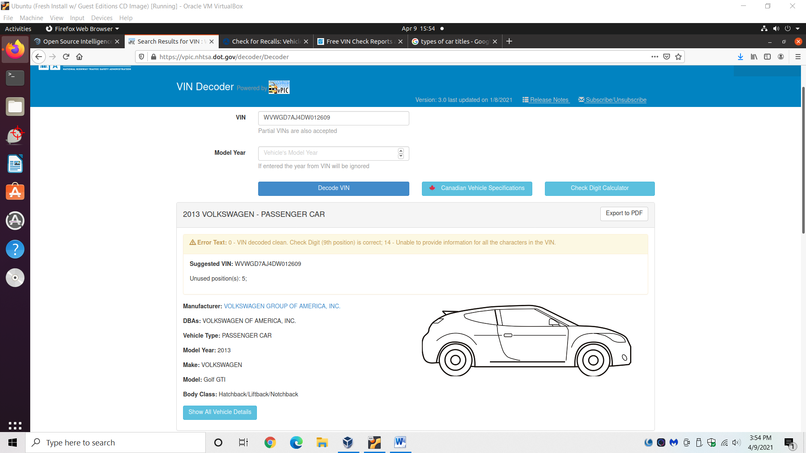

**What type of title do both of these cars have?**

* Look up the different kinds of titles.
* Assume they’re not brand new cars and guess the correct type of title.
* Answer: Salvaged

**What is the NHTSA campaign for the most recent recall on VIN 1?**

* Go to <https://vincheck.info/check/load-nmvtis-report.php>
* Look at NHTSA Recall #.
* Answer: 20V-769

